**Hanson 3**

1. Search and select DevOps Starter.

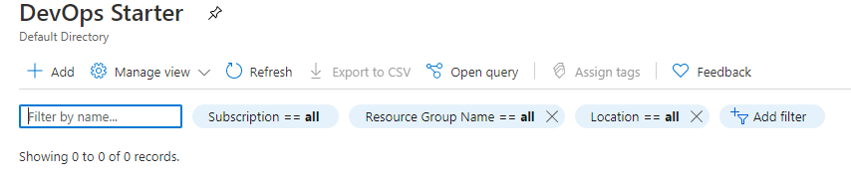

1. Select Add and scroll down to select :

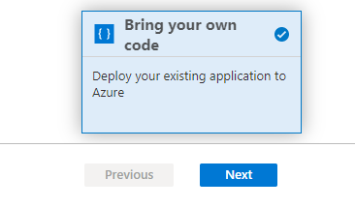

1. In Code repository select github and authorize it.

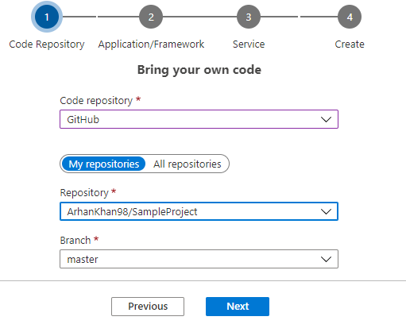

1. Select framework and click next

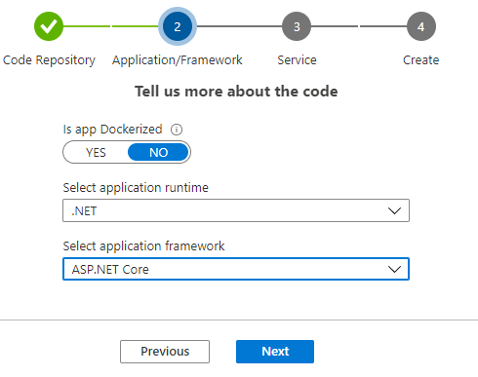

1. Select Server

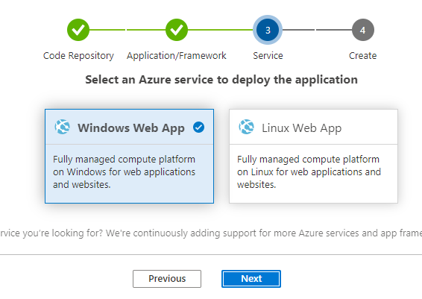

1. Give the project name :

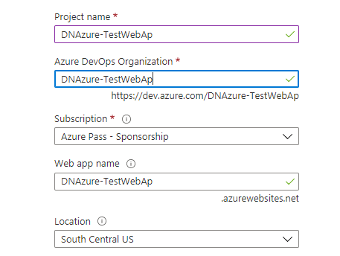

1. The project will start to build , to check the job sequence click on jobs

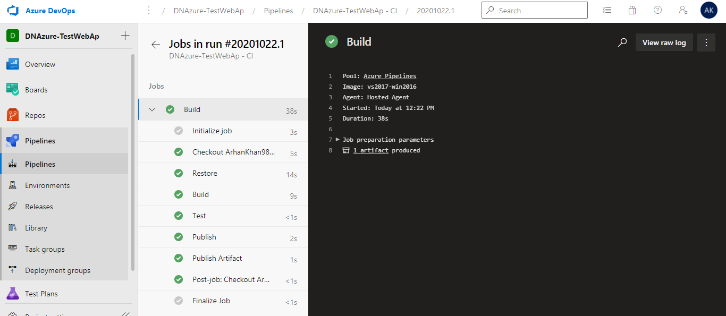

1. To check the release , go to the release and select the dev in the right hand corner .

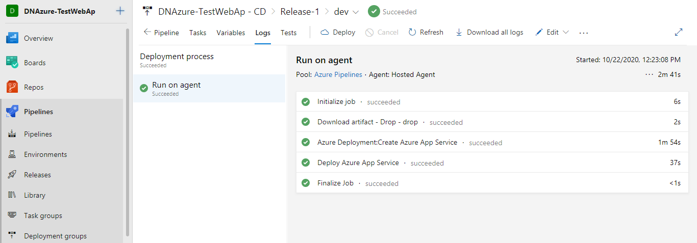

1. Go to home and select the browse option

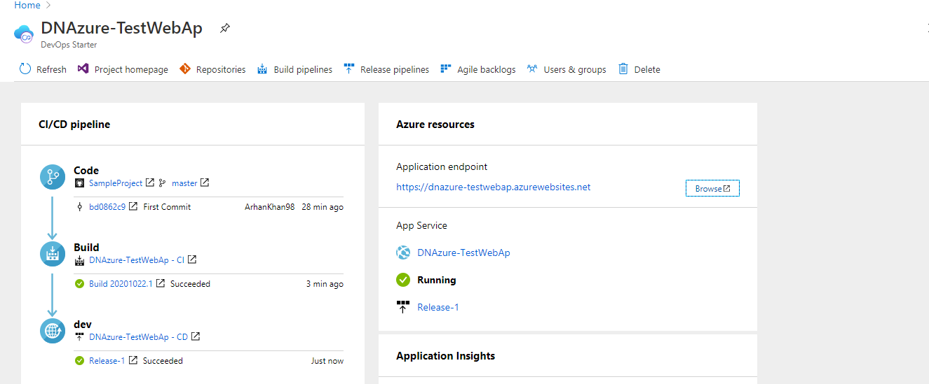

1. Add /weatherforecast to see the result

